**ELECTRIC VEHICLE CHARGEING NETWORK MANAGEMENT**

# TEAM LEADER:

# P.KANISHKAR

**TEAM MEMBERS:**

# S.ROHAN

# A.VISHWANATHAN

**SOURCE CODE**

import pybamm

#choose the model

EV = pybamm.lithium_ion.SPMe()

#simulate with parameters(default)

sim = pybamm.Simulation(EV)

#call solver

sim.solve([1,28800]) #8 hour

sim.plot()

import pybamm

#choose the model

models = [

pybamm.lithium_ion.SPM(), pybamm.lithium_ion.SPMe()

]

#simulate with parameters(default)

#call solver

sims = []

for model in models:

sim = pybamm.Simulation(model)

sim.solve([0,8])

sims.append(sim)

pybamm.dynamic_plot(sims, time_unit = "hours")

sim.plot(["Current [A]", "Terminal voltage [V]","Electrolyte current density" ])

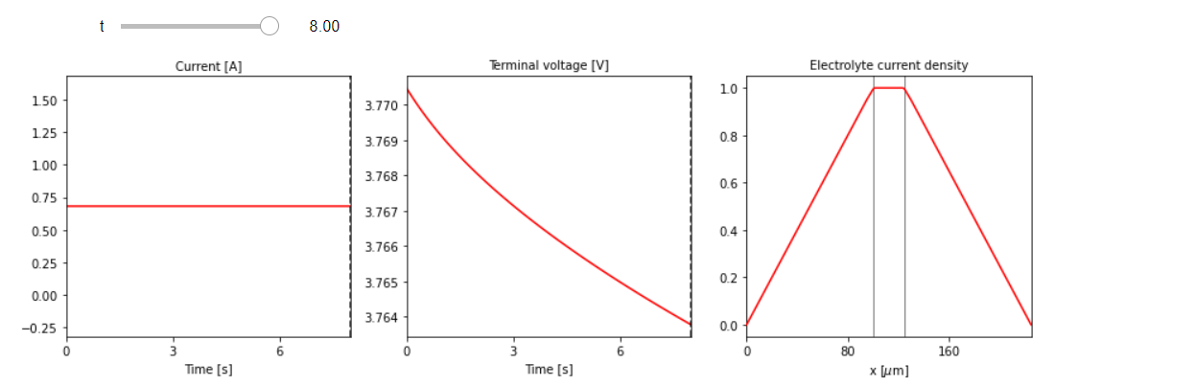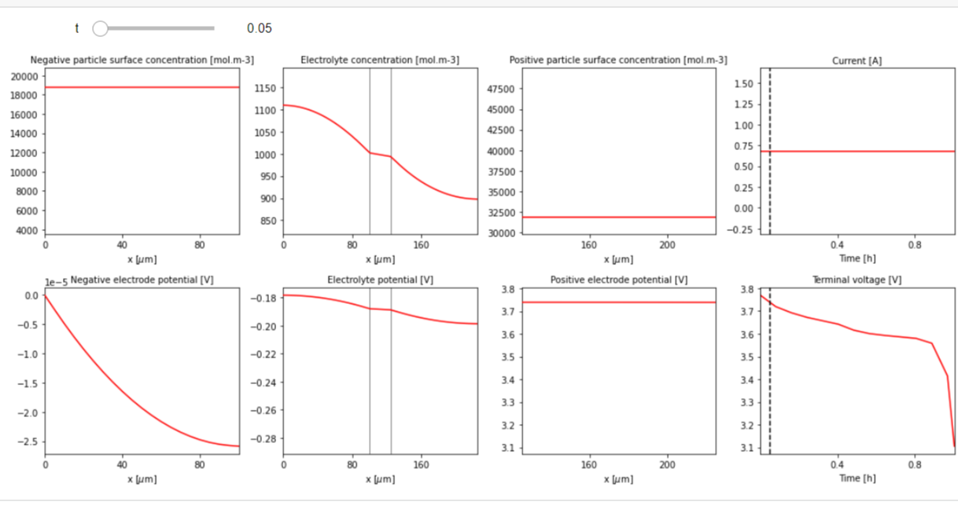

***DEMO 1***

**Demo 2**

